# Practical No: 1

Aim: Write a node.js application to create arithmetic operation (Addition, Subtraction, multiplication, Division)

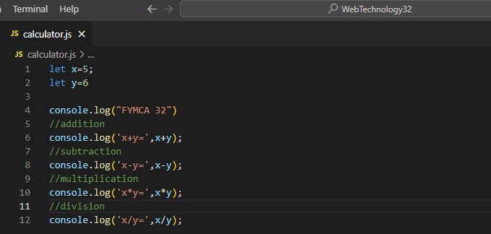

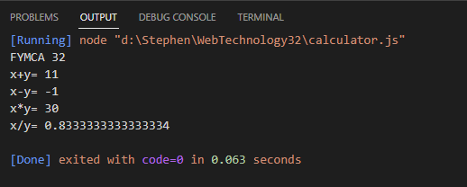

Practical No: 2

Aim: Write an application to demonstrate callback function.

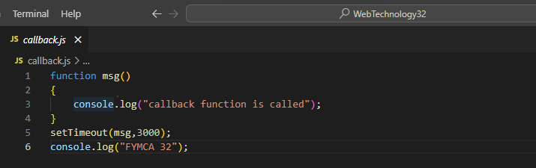

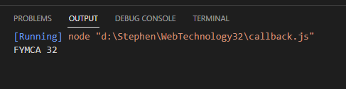

Practical No: 3

Aim: Write an application to demonstrate arrow function.

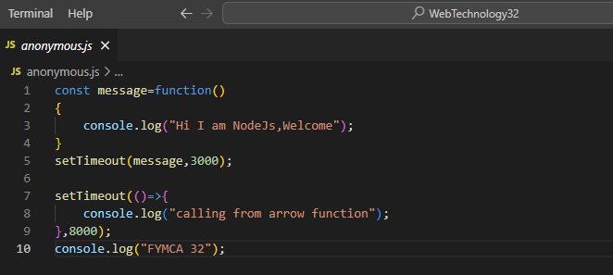

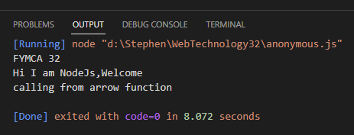

Practical No: 4

Aim: Write an application to display Fibonacci series.

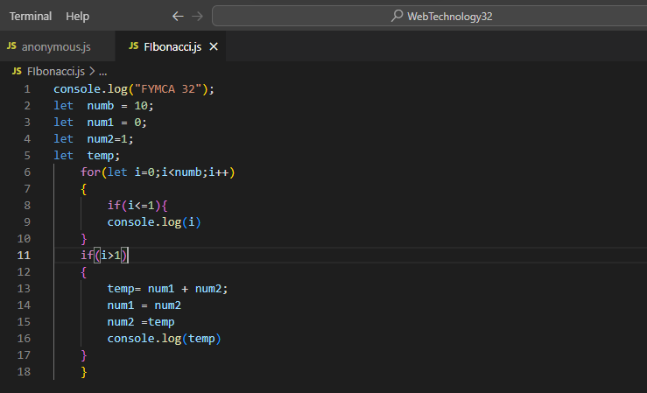

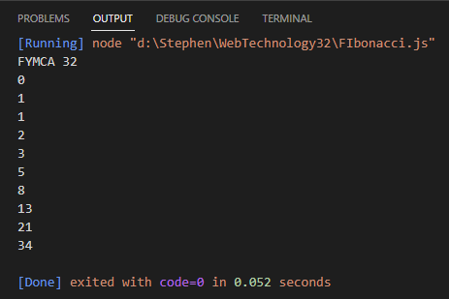

Practical No: 5

Aim: Write an application to display 1 to 10 prime numbers.

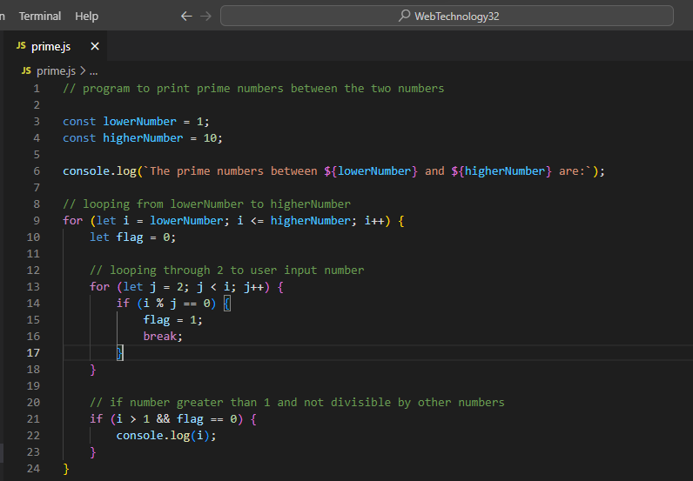

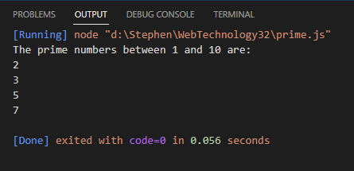

Practical No: 6

Aim: Write an application to demonstrate module.

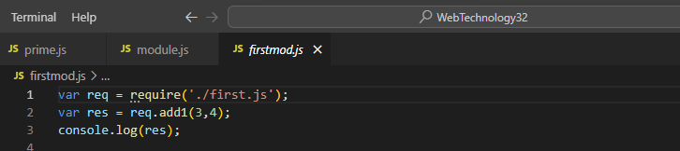

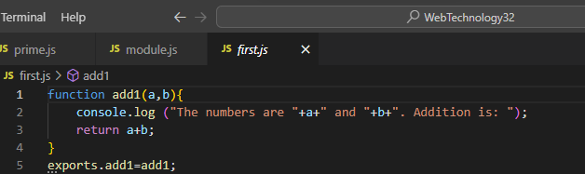

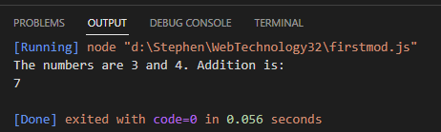

Practical No: 7

Aim: Write a node.js application to find area of circle, square, and rectangle using module.

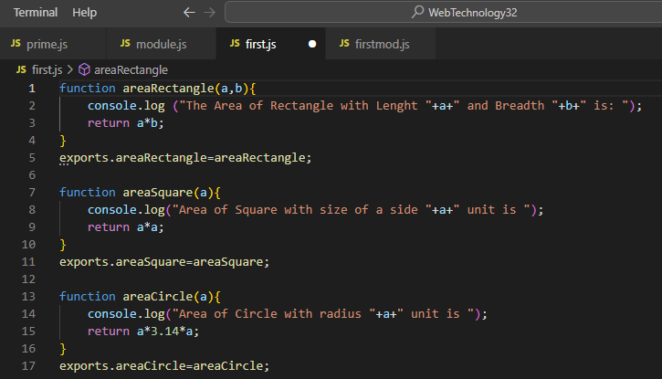

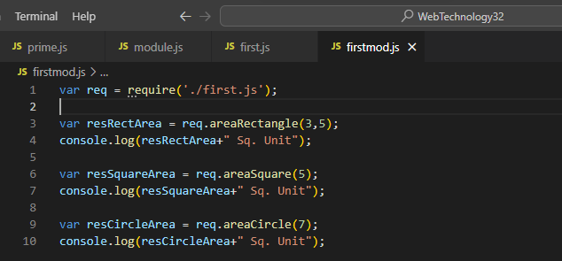

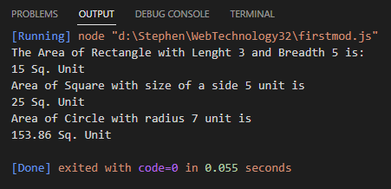

Practical No: 8

Aim: Write an application to demonstrate events module.

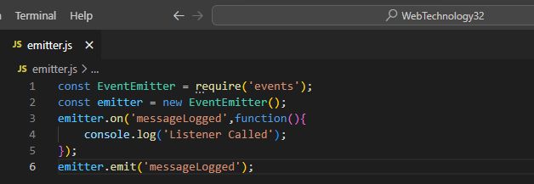

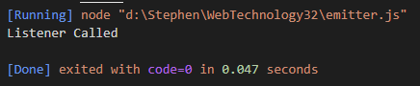

Practical No: 9

Aim: Write an application to demonstrate Events functions (removeListener, listenerCount)

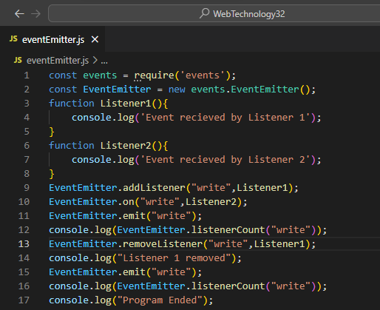

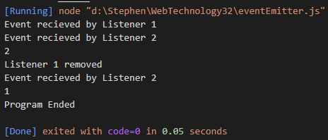

# PRACTICAL No.:-10

AIM: Create an application in nodejs to create Return Event Emitter.

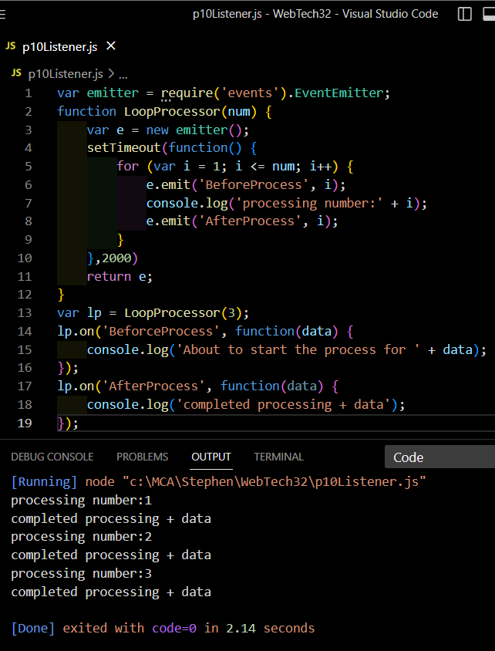

# PRACTICAL No.:-11

AIM: Create an application in nodejs to create Extent Event Emitter.

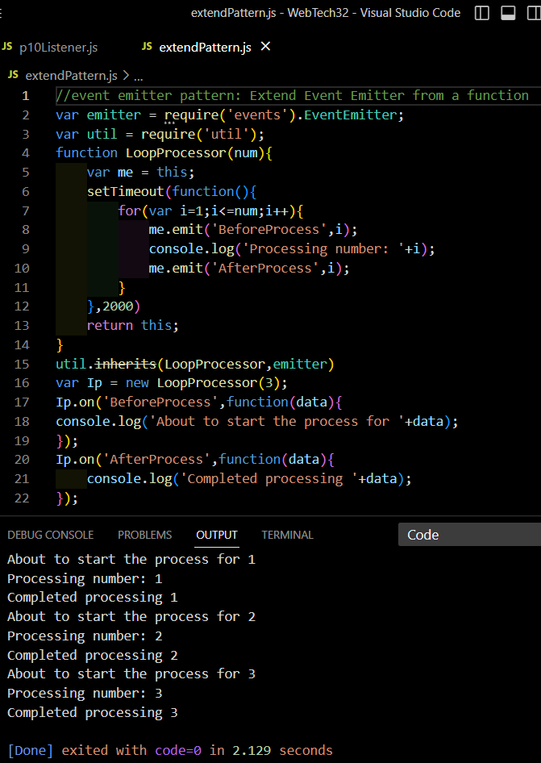

# PRACTICAL No.:-12

AIM: Create an application in nodejs to display message after 5 second & 10 second.

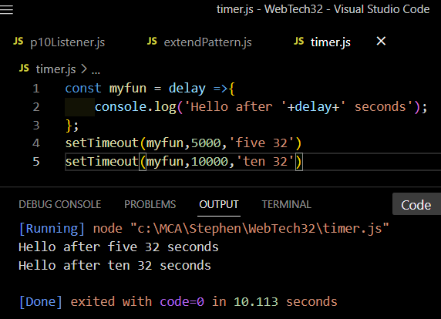

# PRACTICAL No.:-13

AIM: Create an application in nodejs to demonstrate set Interval Function.

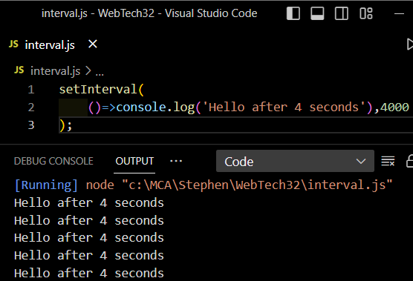

ctr + c: To exit

# PRACTICAL No.:-14

AIM: Create an application in nodejs to display factorial of a number.

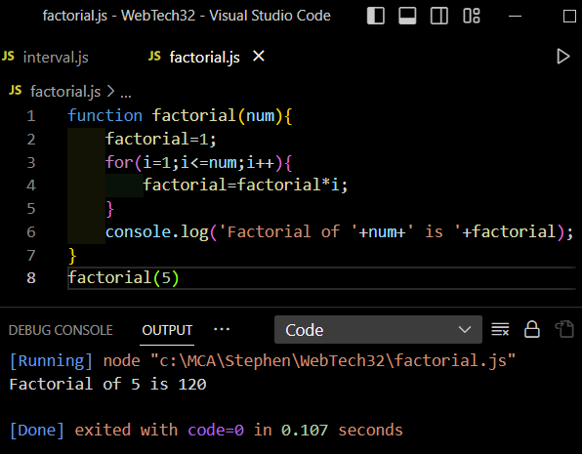

# PRACTICAL No.:-15

AIM: Write as application to create http Server and Display message.

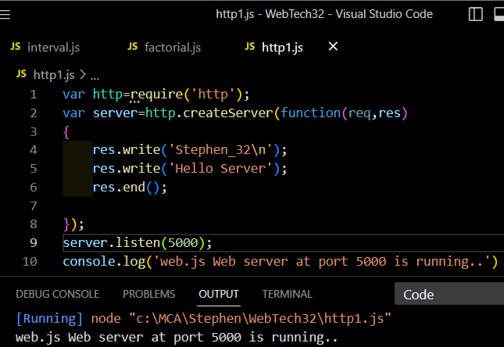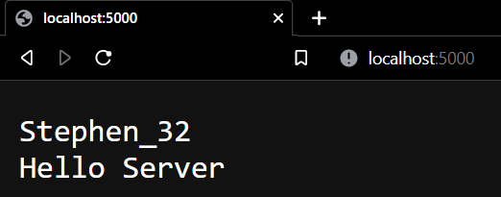

# PRACTICAL No.:-16

AIM: Write as application to create Home page, Admin page and Student page using http server.

var http = require('http');

const {

text

} = require('stream/consumers');

var server = http.createServer(function(req, res) {

if (req.url == '/') {

res.writeHead(200, {

'content-type': 'text/html'

});

res.write('<html></head><body>');

res.write('<style>ul li{display: inline-block; float: right; height: 40px;} ul li a{padding: 20px; background:orange; color: white;}</style>');

res.write('<div><h1>My First Website</h1></div><div><ul><li><a href="/admin">Contact Admin</a></li> <li><a href="/student">Student</a></li> <li><a href="/home">Home</a></li></ul></div></div>');

res.write('<div style="background: white; padding: 20px;"><h2>Start Page</h2><p>This is my first webpage hehe!</p><p>Hi everyone</p></div></body></html>');

res.end();

} else if (req.url == '/home') {

res.writeHead(200, {

'content-type': 'text/html'

});

res.write('<html><head><style>body{padding-left: 43px; padding-right:43px; background-color:lightyellow;} </style></head><body><p><h1>This is home page</h1></p><h1>Stephen Nadar</h1><h3>This page is a brief insight to who I am.</h3>');

res.write('<nav style="background-color:black; text-align:center;"><ul><li><a href="/">Start Page</a></li><li><a href="/student">Student</a></li><li><a href="/admin">Admin</a></li></ul></nav></body></html>');

res.end();

} else if (req.url == '/student') {

res.writeHead(200, {

'content-type': 'text/html'

});

res.write('<div style="display: inline-block; float: right; height: 40px; padding: 20px;"><ul> <li><a href="/home">Home</a></li> <li><a href="/">Start Page</a></li> <li><a href="/admin">Contact Admin</a></li></ul></div>');

res.write('<html><head><style>body{background-color:pink;}</style> <title>Form</title></head><body bgcolor="White" > <h1 align="center">Student Page Form</h1>');

res.write('<form action="url" method="post"><fieldset><legend>Personal Imformation</legend>');

res.write('<lable><Strong>Student Name</strong></lable><br/><input type="text" name="Student Name" placeholder="Enter Your Name" /><br/>');

res.write('<lable><Strong>Email</strong></lable><br/><input type="email" name="eamil" placeholder="Enter Your Email Address" /></br>');

res.write('<lable><Strong>Password</strong></lable><br/>');

res.write('<input type="password" name="Password" placeholder="Enter Your Password" /></br><lable><Strong>Gender</strong></lable><br/>');

res.write('<input type="Radio" name="Gender" value="Male" />Male <input type="Radio" name="Gender" value="FeMale" />FeMale<br/>');

res.write('<lable><Strong>Hobbies</strong></lable><br/>');

res.write('<input type="checkbox" name="Hobbies" value="Playing Sports" />Playing Sports<br/>');

res.write('<input type="checkbox" name="Hobbies" value="Listening Music" />Listening Music<br/>');

res.write(' <input type="checkbox" name="Hobbies" value="Traveling" />Traveling<br/> <input type="checkbox" name="Hobbies" value="Reading Books" />Reading Books<br/>');

res.write('<lable><Strong>Select Your City</strong></lable><select name="City">');

res.write('<option value="Ahemdabad">Ahemdabad</option><option value="Kalol">Kalol</option><option value="Surat">Surat</option>');

res.write(' <option value="Rajkot">Rajkot</option></select></br><input type="submit" onclick=alert("Thanks!") name="submit" value="Submit"/></form>');

res.end();

} else if (req.url == '/admin') {

res.writeHead(200, {

'content-type': 'text/html'

});

res.write('<style>ul li{display: inline-block; float: right; height: 40px;} ul li a{padding: 20px; background:orange; color: white;}</style>');

res.write('<div><ul><li><a href="/admin">Contact Admin</a></li> <li><a href="/student">Student</a></li> <li><a href="/home">Home</a></li></ul></div></div><br><br>');

res.write('<html><head><style>legend{text-align:center;} body{background-color:faf89a;border: 5px solid darkred;} form{display: inline-block; float: center; padding: 20px;} ');

res.write('border-radius:4px; padding:40px 5px; max-width:100%;}</style></head>');

res.write('<legend><h1><u>Admin Login</u></h1></legend>');

res.write('<form action="#" method="POST" autocomplete="off">');

res.write('<div class="input_field"><h3>Username</h3></div><div class="input_field"><input type="text" ');

res.write('name="userid" placeholder="Username" required/></div>');

res.write('<div class="input_field"><h3>Password</h3></div><div class="input_field"><input type="Password"');

res.write('name="pword" placeholder="Password" required/></div><p>');

res.write('<style>button{border:none; border-radius:5px; text-align:center; padding:15px 15px; background-color:lavender;<div></div></style>');

res.write('<button onclick=alert("SUCESS")>LOGIN NOW</button></form>');

res.end();

} else {

res.end('Invalid request');

}

});

server.listen(9000);

console.log('Node.js web server at port 9000 is running');

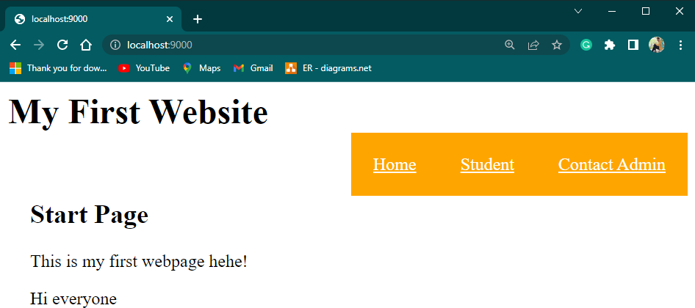

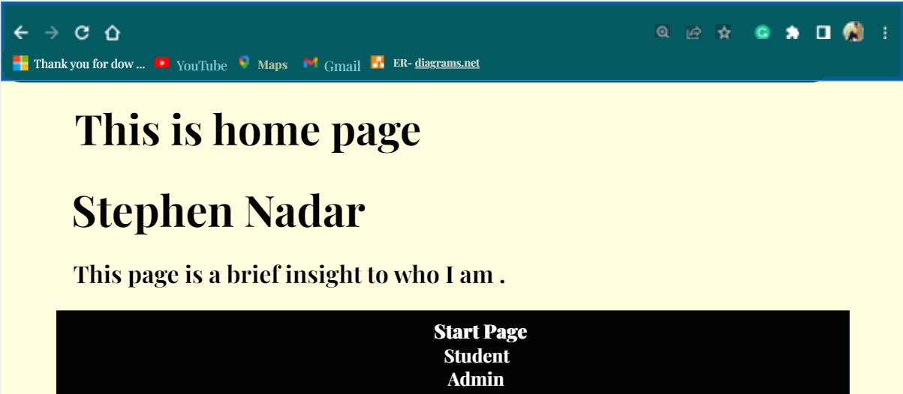

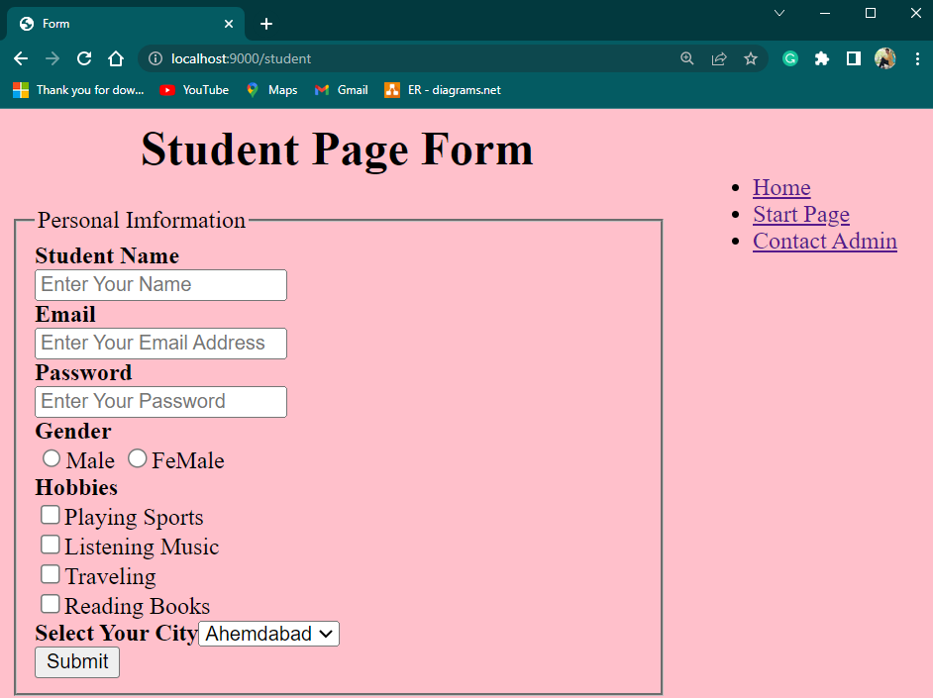

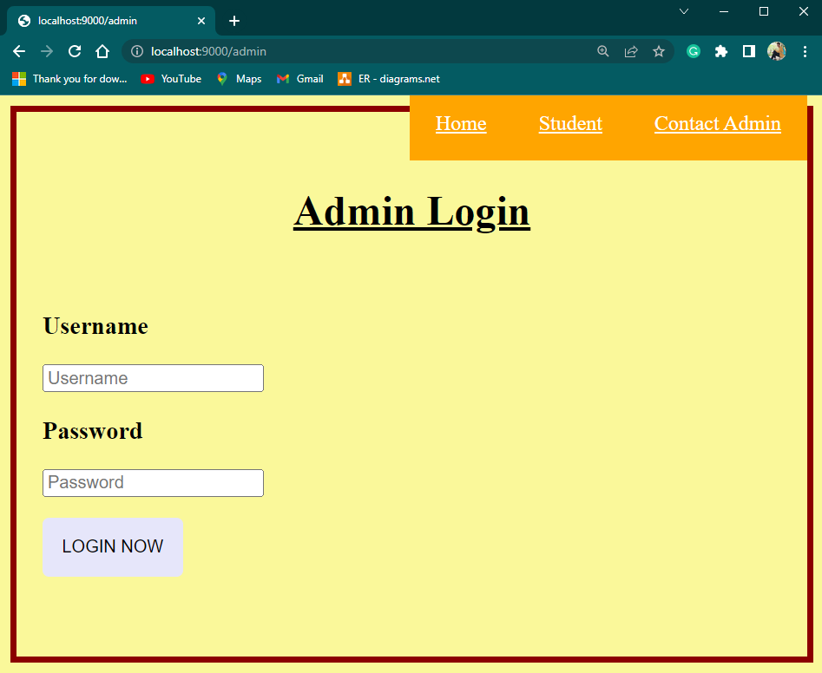

# PRACTICAL No.:-17

AIM: Write in application to display details of the current file path.

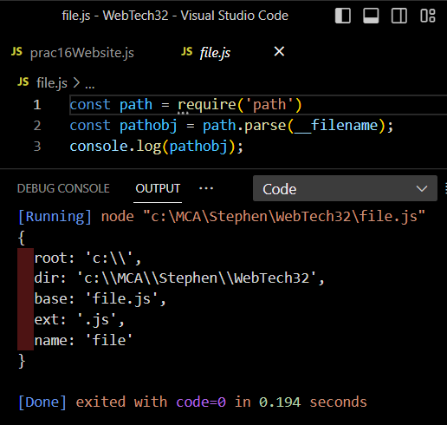

# PRACTICAL No.:-18

AIM: Write an application to read file.

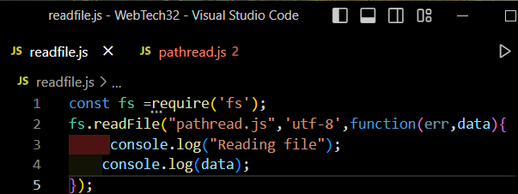

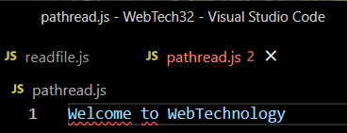

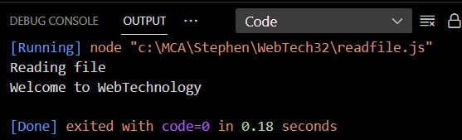

# PRACTICAL No.:-19

AIM: Write an application to write in file.

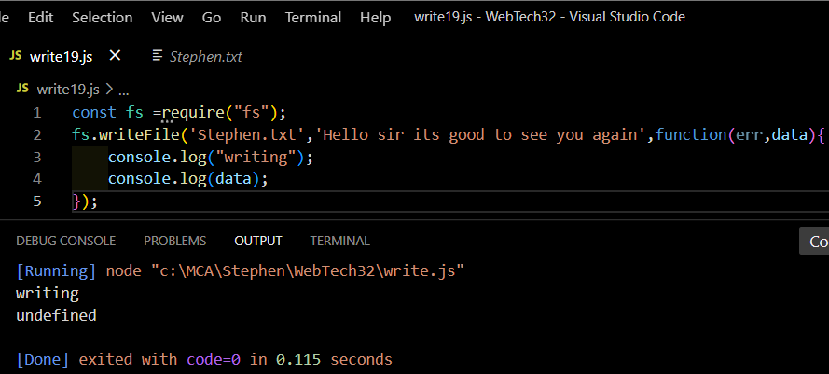

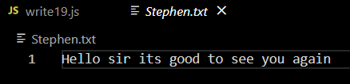

# PRACTICAL No.:-20

AIM: Write an application to add data in file.

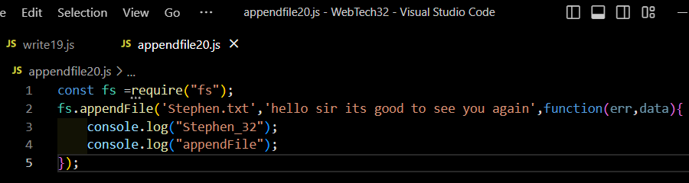

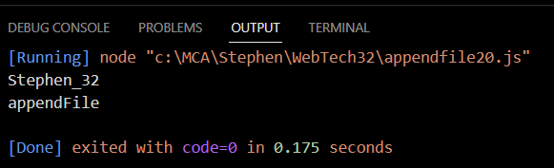

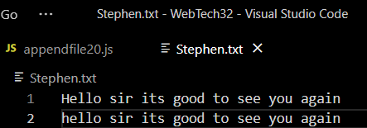

# PRACTICAL No.:-21

AIM: Write an application to delete a file.

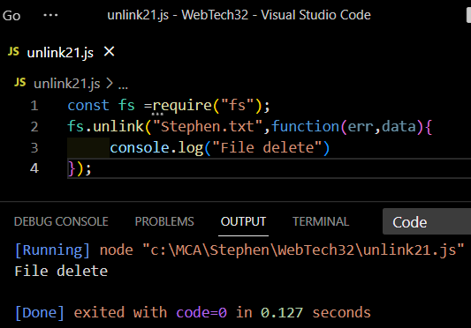

# PRACTICAL No.:-22

AIM: Write an application to rename a file.

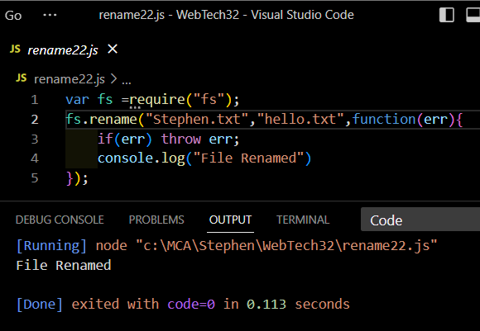

# PRACTICAL No.:-23

AIM: Create an Application to create Database.

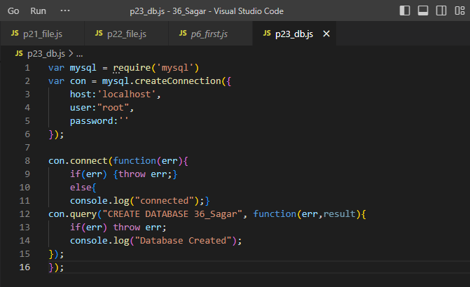

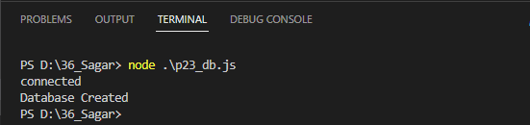

# PRACTICAL No.:-24

AIM: Create an Application to create Student table with columns as id, name, address, course, contact.

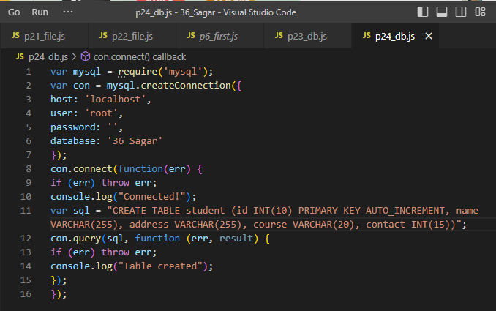

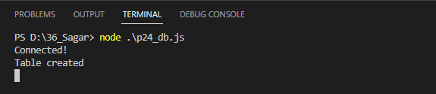

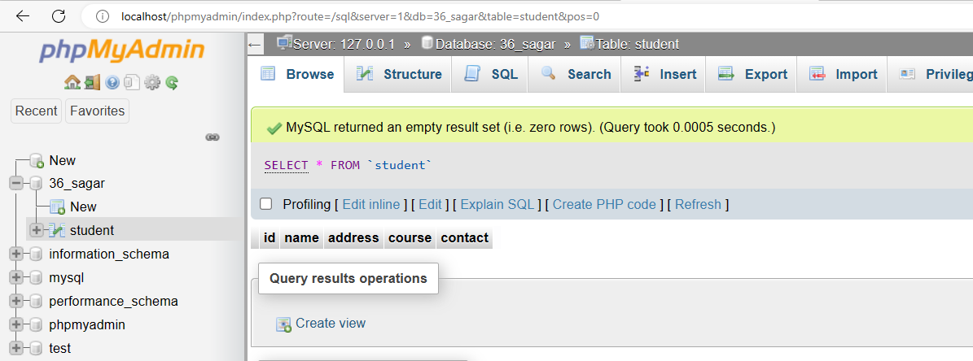

# PRACTICAL No.:-25

AIM: Create an Application to insert rows into Student table.

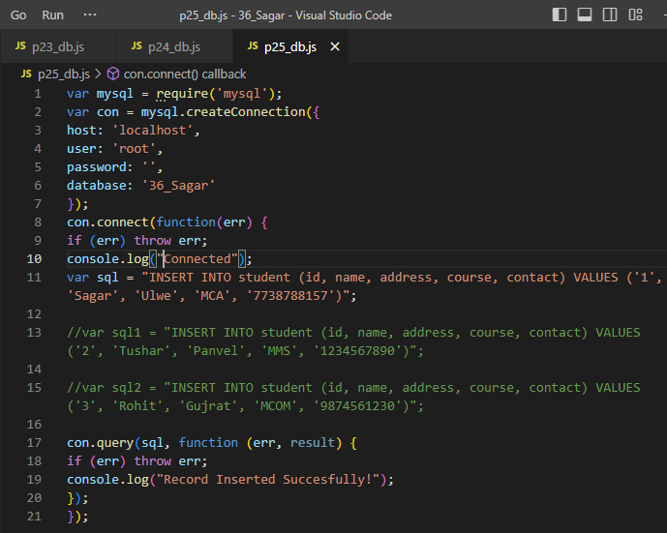

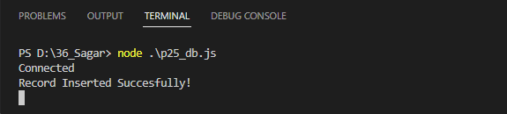

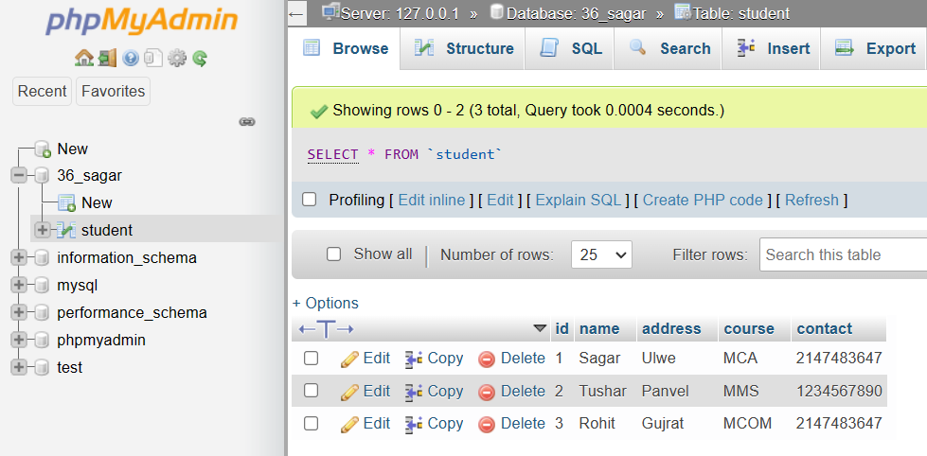

# PRACTICAL No.:-26

AIM: Create an Application to display rows into Student table.

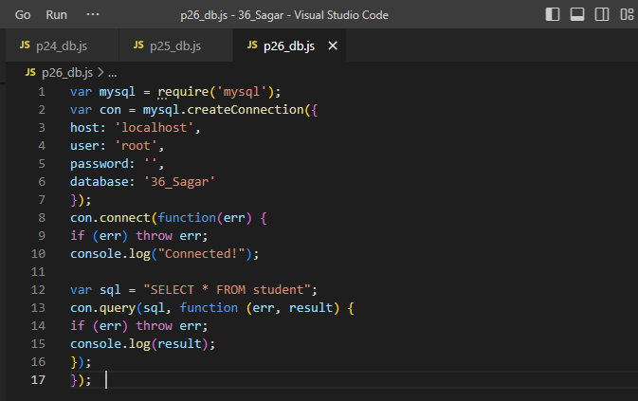

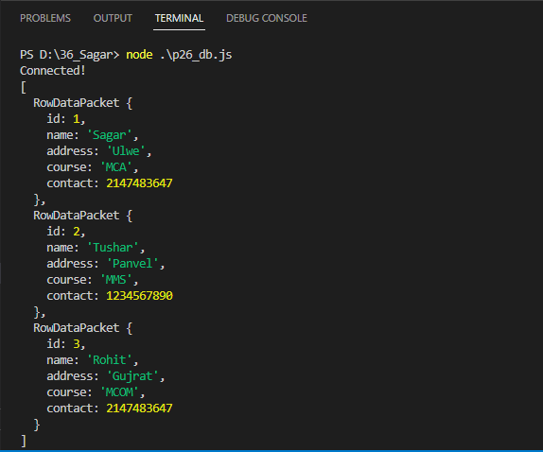

# PRACTICAL No.:-27

AIM: Create an Application to update rows into Student table.

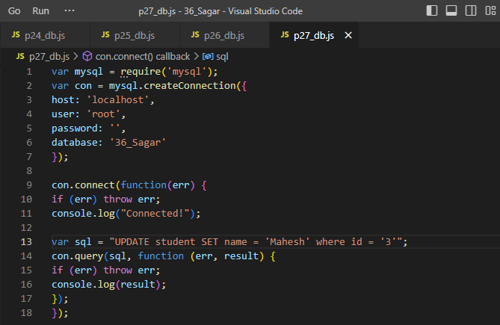

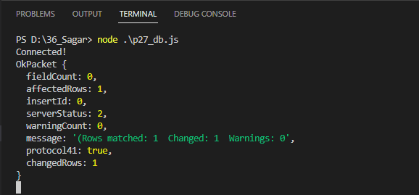

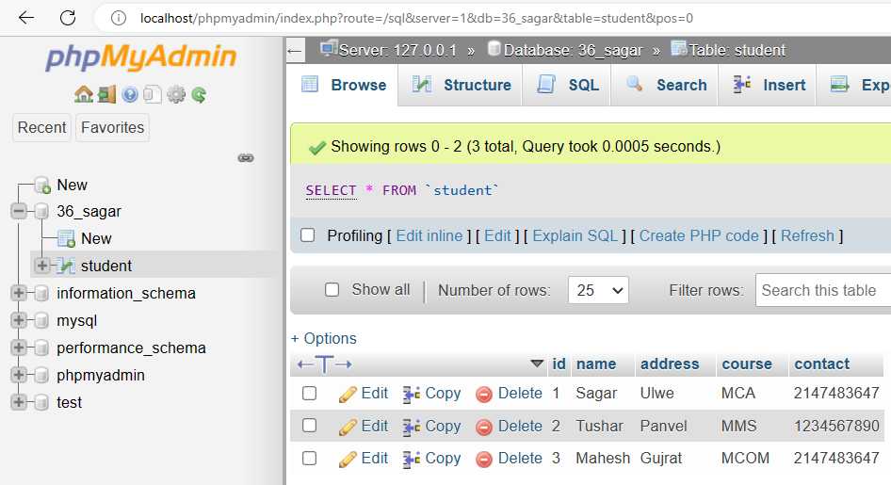

# PRACTICAL No.:-28

AIM: Create an Application to add column to Student table.

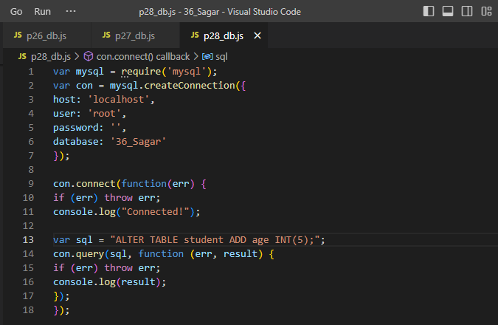

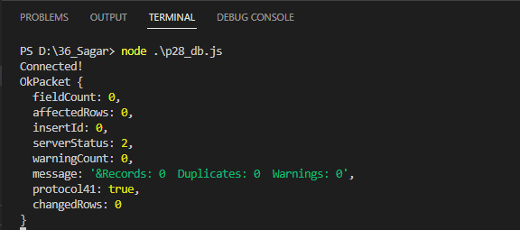

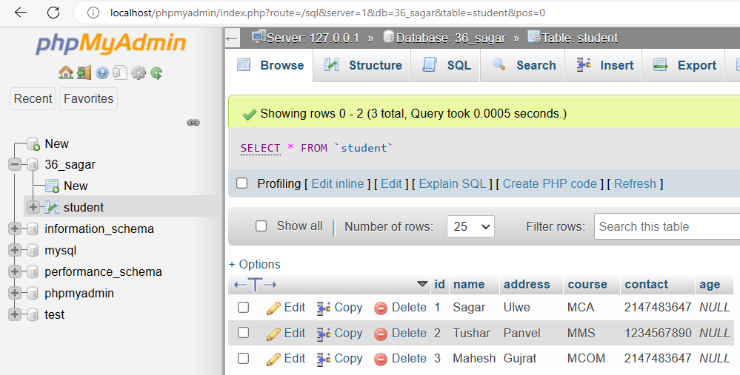

# PRACTICAL No.:-29

AIM: Create an Application to delete records in Student table.

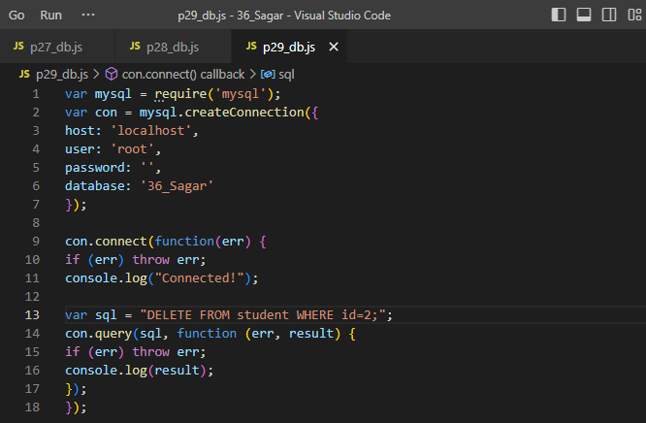

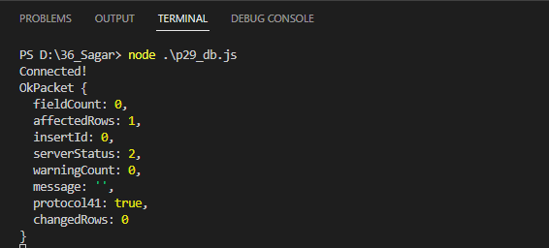

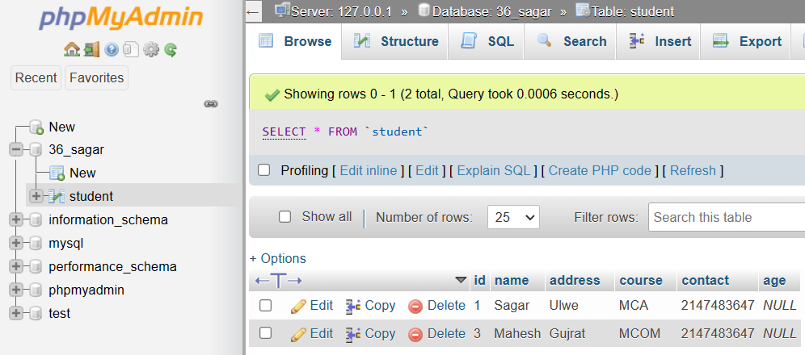

# PRACTICAL No.:-30

AIM:  Create an Application to demonstrate an Array.

<!DOCTYPE html>

<html lang="en">

<head>

<meta charset="UTF-8">

<meta http-equiv="X-UA-Compatible" content="IE=edge">

<meta name="viewport" content="width=device-width, initial-scale=1.0">

<title>Document</title>

<script src="angular.min.js"> </script>

</head>

<body>

<h1>Welcome to Angular</h1>

<p ng-app="" ng-init="points=[2,3,10,40]"></p>

<p>The Second element in array is {{points[1]}}</p>

</div>

</body>

</html>

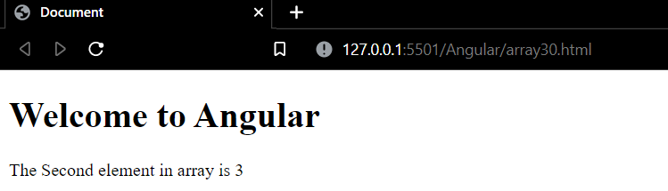

# PRACTICAL No.:-31

AIM:  Create an Application to demonstrate an Array and Display the elements in Ordered List.

<!DOCTYPE html> <html lang="en">

<head>

<meta charset="UTF-8">

<meta http-equiv="X-UA-Compatible" content="IE=edge">

<meta name="viewport" content="width=device-width, initial-scale=1.0">

<title>Document</title>

<script src="angular.min.js"> </script>

</head>

<body>

<div ng-app = "">

<h1>Welcome to Angular</h1>

<p ng-app="" ng-init="points=[2,3,10,40]"></p>

<p>The element in array are {{points}}</p>

</div>

</body>

</html>

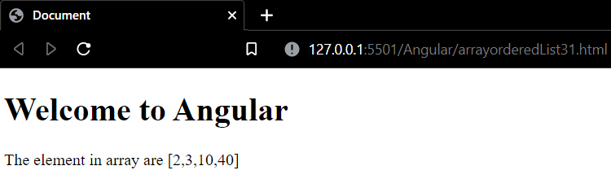

# PRACTICAL No.:-32

AIM:  Create an application to Display Marksheet of a Student.

<!DOCTYPE html>

<html lang="en">

<head>

<meta charset="UTF-8">

<meta http-equiv="X-UA-Compatible" content="IE=edge">

<meta name="viewport" content="width=device-width, initial-scale=1.0">

<script src="angular.min.js"></script>

<title>Document</title>

</head>

<style>

* body{color: blanchedalmond;

background-image: linear-gradient(to right, purple, blue);}

#nc {

color: blue;

background-color: yellow;

border: 6px solid salmon;

text-align: center;

}

.center {

display: block;

margin-left: auto;

margin-right: auto;

width: 50%;

}

#name {

margin-top: 50px;

margin-bottom: 50px;

margin-right: 80px;

margin-left: 80px;

}

</style>

<body class="body">

<form>

<h1 id="nc">

NCRD's Sterling Institute Of Managment Studies</h1>

<img class="center" src="http://www.ncrdsims.edu.in/site/views/images/NCRD-logo.png" height="100" width="600">

<h2 id="name">

<element style="color: rgb(255, 215, 120)"> NAME :</element> STEPHEN NADAR

<br>

<element style="color: rgb(255, 215, 120)">Roll No :</element> 32

<br>

<element style="color: rgb(255, 215, 120)">Marks in SEM 1 :</element>

</h2>

<h2 id="name">

<element ng-app="" ng-init=" marks =[{ sub:'Node', mark:80}, {sub:'Java', mark:97}, {sub:'SPM', mark:90}]">

<ul>

<li ng-repeat="x in marks">

{{x.sub+' : '+x.mark}}

</li>

</ul>

</element>

</h2>

</form>

</body>

</html>

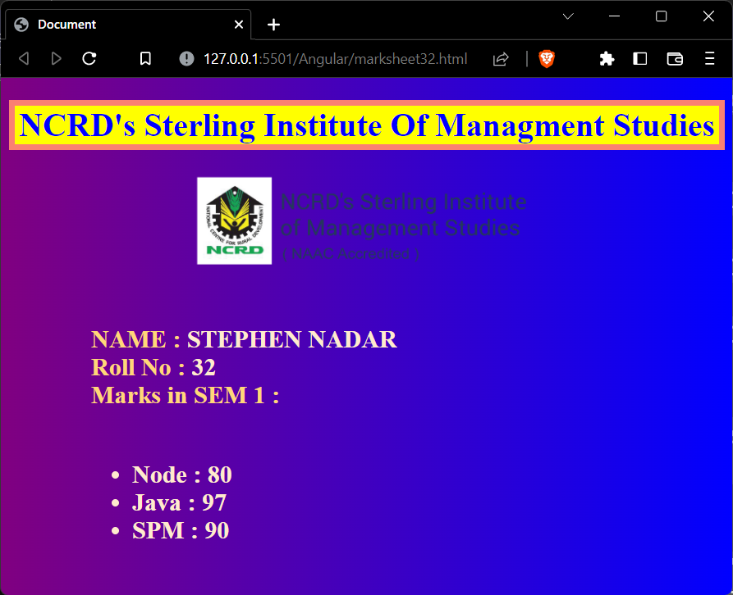

# PRACTICAL No.:-33

AIM:  Create an Application in AngularJS to change background colour of a textbox as written in the textbox.

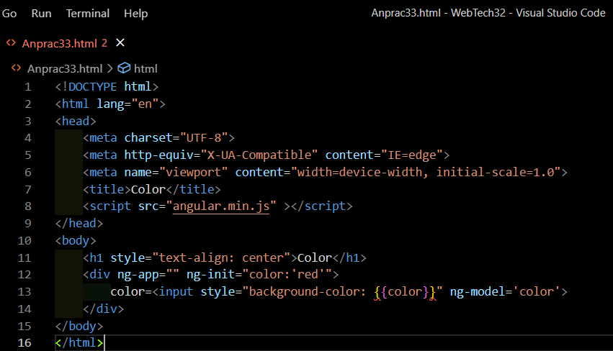

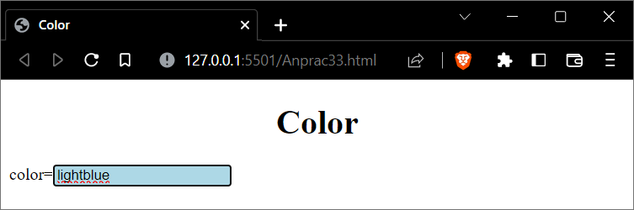

# PRACTICAL No.:-34

AIM:  Create an Application in AngularJS to calculate Area and Perimeter.

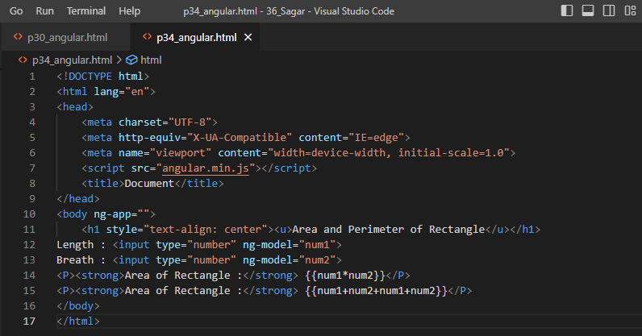

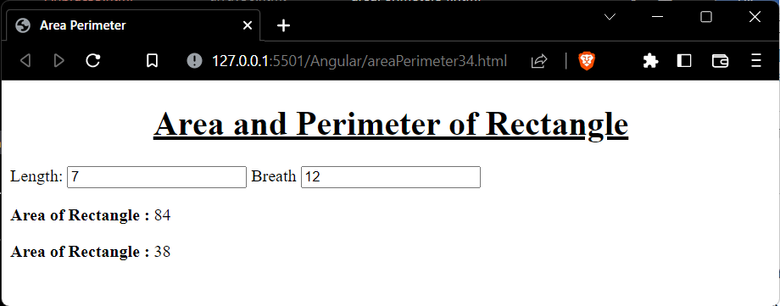

# PRACTICAL No.:-35

AIM:  Create an Application in AngularJS to Demonstrate Controllers.

<!DOCTYPE html>

<html lang="en">

<head>

<meta charset="UTF-8">

<meta http-equiv="X-UA-Compatible" content="IE=edge">

<meta name="viewport" content="width=device-width, initial-scale=1.0">

<title>Controllers</title>

<script src="angular.min.js" ></script>

</head>

<body ng-app ng-init="checked=true">

Click Me:<input type="checkbox" type="text" ng-model="checked"><br/>

<div>

New:<input ng-if="checked" type="text">

</div>

<div>

Read-only:<input ng-readonly="checked" type="text"

value="This is read-only">

</div>

<div>

Disabled:<input ng-disabled="checked" type="text"

value="This is Disabled">

</div>

</body>

</html>

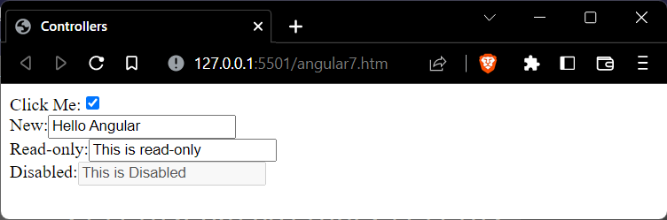

# PRACTICAL No.:-36

AIM:  Create an Application to Display Marksheet of a Student.

<!DOCTYPE html>

<html lang="en">

<head>

<meta charset="UTF-8">

<meta http-equiv="X-UA-Compatible" content="IE=edge">

<meta name="viewport" content="width=device-width, initial-scale=1.0">

<title>Document</title>

<script src="angular.min.js"></script>

<style>

body {

font-family: Arial;

}

table {

border-collapse: collapse;

}

td {

border: 1px solid black;

padding: 5px;

}

th {

border: 1px solid black;

padding: 5px;

text-align: left;

}

</style>

</head>

<body ng-app="myModule">

<div ng-controller="myController">

Rows to display : <input type="number" step="1" ng-model="rowCount" max="10" min="0" />

<br /><br />

<table>

<thead>

<tr>

<th>Name</th>

<th>Date of Birth</th>

<th>Gender</th>

<th>Salary (number filter)</th>

<th>Salary (currency filter)</th>

</tr>

</thead>

<tbody>

<tr ng-repeat="employee in employees | limitTo:rowCount">

<td> {{ employee.name | uppercase }} </td>

<td> {{ employee.dateOfBirth | date:"dd/MM/yyyy" }} </td>

<td> {{ employee.gender }} </td>

<td> {{ employee.salary | number:2 }} </td>

<td> {{ employee.salary | currency : "₹" : 1 }} </td>

</tr>

</tbody>

</table>

</div>

</body>

<script>

var app = angular

.module("myModule", [])

.controller("myController", function ($scope) {

var employees = [

{

name: "Stephen", dateOfBirth: new Date("November 22, 2001"),

gender: "Male", salary: 55000.788,

},

{

name: "Jenny", dateOfBirth: new Date("April 05, 1999"),

gender: "Female", salary: 68000,

},

{

name: "Matthew", dateOfBirth: new Date("October 13, 2002"),

gender: "Male", salary: 57000,

},

{

name: "Natasha", dateOfBirth: new Date("June 11, 2001"),

gender: "Female", salary: 53000,

},

{

name: "John", dateOfBirth: new Date("January 18, 2001"),

gender: "Male", salary: 60000,

},

{

name: "Gwen", dateOfBirth: new Date("May 14, 2003"),

gender: "Female", salary: 53000,

},

];

$scope.employees = employees;

$scope.rowCount = 5;

});

</script>

</html>

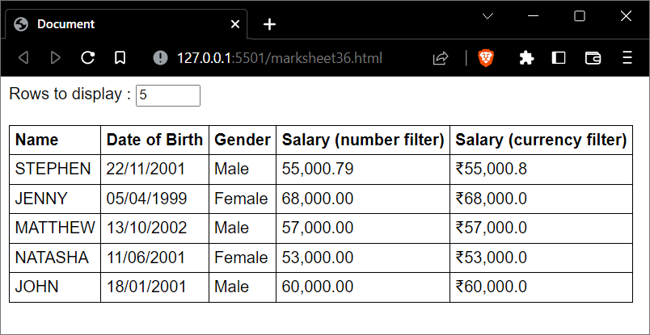

# PRACTICAL No.:-37

AIM:  Create an Application in Angular to display list of Programming languages (likes and dislikes)

<!DOCTYPE html>

<html lang="en">

<head>

<meta charset="UTF-8">

<meta http-equiv="X-UA-Compatible" content="IE=edge">

<meta name="viewport" content="width=device-width, initial-scale=1.0">

<title>Document</title>

<script src="angular.min.js" ></script>

<script src="angweb.js"></script>

<link href="fourth.css" rel="stylesheet"/>

</head>

<body ng-app="myModule">

    <div ng-controller="myController">

        <table>

            <thead>

                <tr>

                    <th>Name</th>

                    <th>Likes</th>

                    <th>Dislikes</th>

                    <th>Like/Dislike</th>

                </tr>

            </thead>

        <tbody>

            <tr ng-repeat="technology in technologies">

                <td>{{technology.name}}</td>

                <td style="text-align: center;">{{technology.likes}}</td>

                <td style="text-align: center;">{{technology.dislike}}</td>

                <td>

                    <input type="button" ng-click="incrementLikes(technology)" value="Like">

                    <input type="button" ng-click="incrementDisLikes(technology)" value="Dislike">

                </td>

            </tr>

        </tbody>

    </table>

    </div>

</body>

</html>

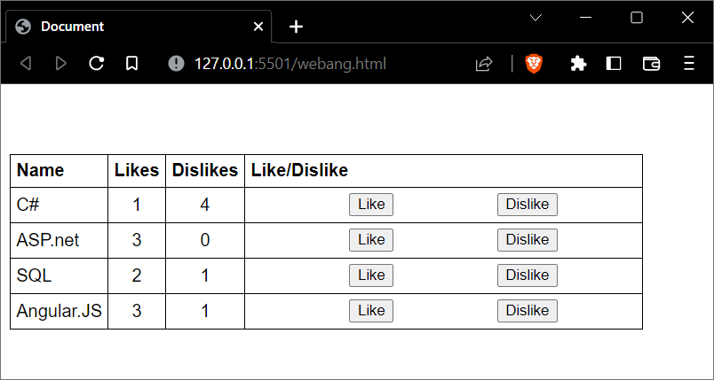

# PRACTICAL No.:-38

AIM:  Create an Application in AngularJS to change the background colour of a division using ng-switch directive.

<!DOCTYPE html>

<html lang="en">

<head>

<meta charset="UTF-8">

<meta http-equiv="X-UA-Compatible" content="IE=edge">

<meta name="viewport" content="width=device-width, initial-scale=1.0">

<title>Document</title>

<script src="angular.min.js"></script>

</head>

<body ng-app="">

<div>

<form>

Select Color:

<select ng-model="myVar">

<option value="pink">Pink

<option value="skyblue">Skyblue

<option value="lav">Lavender

<option value="vio">Violet

<option value="ind">Indigo

<option value="blu">Blue

<option value="gre">Green

<option value="yel">Yellow

<option value="ora">Orange

<option value="red">Red

</select>

</form>

</div>

<div ng-switch="myVar">

<div ng-switch-when-> </div>

<div ng-switchmyVar>

<div ng-switch-when="pink" style="background-color: pink;">

<h1>Pink</h1>

<p>Pink Color</p>

</div>

</div>

<div ng-switch="myVar">

<div ng-switch-when="skyblue" style="background-color: rgb(19, 165, 214);">

<h1>Sky Blue</h1>

<p>Sky Blue Color.</p>

</div>

</div>

<div ng-switch="myVar">

<div ng-switch-when="lav" style="background-color: rgb(226, 184, 253)">

<h1>Lavender</h1>

<p>Lavender Color</p>

</div>

</div>

<div ng-switch="myVar">

<div ng-switch-when="vio" style="background-color: rgb(101, 75, 250)">

<h1>Violet</h1>

<p>Violet Color</p>

</div>

</div>

<div ng-switch="myVar">

<div ng-switch-when="ind" style="background-color: rgb(169, 104, 209)">

<h1>Indigo</h1>

<p>Indigo Color</p>

</div>

</div>

<div ng-switch="myVar">

<div ng-switch-when="blu" style="background-color: rgb(38, 78, 255)">

<h1>Blue</h1>

<p>Blue Color</p>

</div>

</div>

<div ng-switch="myVar">

<div ng-switch-when="gre" style="background-color: rgb(0, 255, 34)">

<h1>Green</h1>

<p>Green Color</p>

</div>

</div>

<div ng-switch="myVar">

<div ng-switch-when="yel" style="background-color: rgb(255, 251, 0)">

<h1>Yellow</h1>

<p>Yellow Color</p>

</div>

</div>

<div ng-switch="myVar">

<div ng-switch-when="ora" style="background-color: rgb(255, 180, 93)">

<h1>Orange</h1>

<p>Orange Color</p>

</div>

</div>

<div ng-switch="myVar">

<div ng-switch-when="red" style="background-color: rgb(255, 89, 89)">

<h1>Red</h1>

<p>Red Color</p>

</div>

</div>

<p>The ng-switch directive hides and shows HTM sections depending on the value of the dropdown list.</p>

</body>

</html>

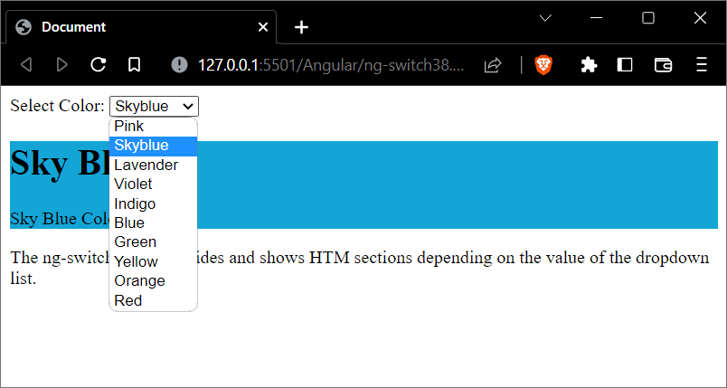

# PRACTICAL No.:-39

AIM:  Create an angular application to demonstrates Mouse event directives- ng-mouse-enter and ng-mouse-leave.

<!DOCTYPE html>

<html>

<head>

<script src="angular.min.js"></script>

<style>

.redDiv {

width: 100px;

height: 100px;

background-color: red;

padding: 2px 2px 2px 2px;

}

.yellowDiv {

width: 100px;

height: 100px;

background-color: yellow;

padding: 2px 2px 2px 2px;

}

</style>

</head>

<body ng-app>

<div ng-class="{redDiv: enter, yellowDiv: leave}" ng-mouseenter="enter=true;leave=false;"

ng-mouseleave="leave=true;enter=false">

Mouse <span ng-show="enter">Enter</span> <span ng-show="leave">Leave</span>

</div>

</body>

</html>

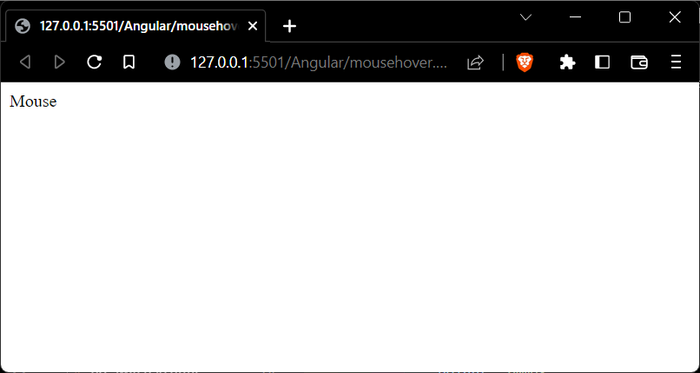

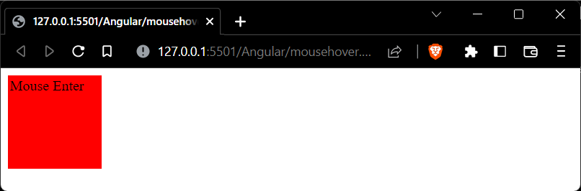

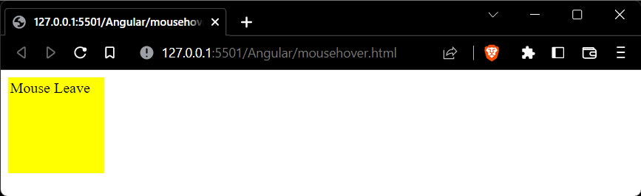

# PRACTICAL No.:-40

AIM:  To create a Registration form with username, email-address gender, and save button.

<!DOCTYPE html>

<html lang="en">

<head>

<meta charset="UTF-8">

<meta http-equiv="X-UA-Compatible" content="IE=edge">

<meta name="viewport" content="width=device-width, initial-scale=1.0">

<title>Document</title>

<script src="angular.min.js"></script>

</head>

<body ng-app="formExample">

<div ng-controller="formController">

<form novalidate>

<label>Name: <input type="text" ng-model="user.name" /></label><br />

<label>E-mail: <input type="email" ng-model="user.email" /></label><br />

Gender: <label><input type="radio" ng-model="user.gender" value="Male" />Male</label>

<label><input type="radio" ng-model="user.gender" value="Female" />Female</label><br />

<input type="submit" ng-click="update(user)" value="Save" />

</form>

<pre>user = {{user | json}}</pre>

<pre>master = {{master | json}}</pre>

</div>

<script>

angular.module('formExample', [])

.controller('formController', ['$scope', function($scope) {

$scope.master = {};

$scope.update = function(user) {

$scope.master = angular.copy(user);

};

}]);

</script>

</body>

</html>

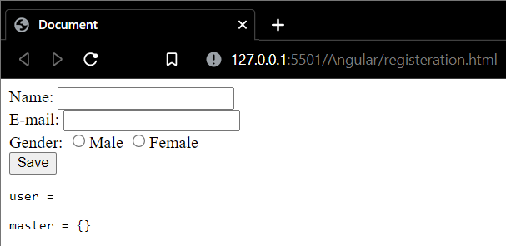

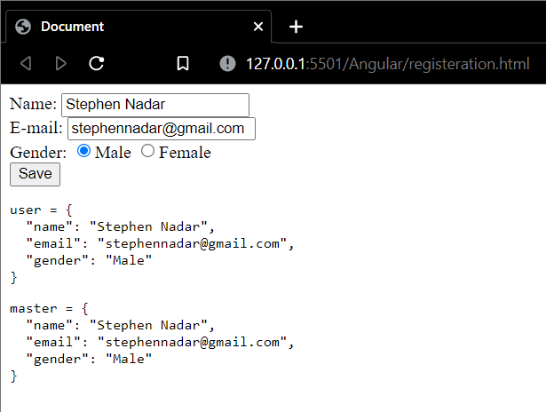

# PRACTICAL No.:-41

AIM:  To create a Registration form with username, email-address gender, and save button.

:

* start.html

<!DOCTYPE html>

<html ng-app="myApp">

<head>

    <link rel="stylesheet" href="//netdna.bootstrapcdn.com/bootstrap/3.0.0/css/bootstrap.min.css" />

    <link rel="stylesheet" href="//netdna.bootstrapcdn.com/font-awesome/4.0.0/css/font-awesome.css" />

    <script src="https://ajax.googleapis.com/ajax/libs/angularjs/1.2.25/angular.min.js"></script>

    <script src="//ajax.googleapis.com/ajax/libs/angularjs/1.2.25/angular-route.js"></script>

    <script src="angular.min.js"></script>

    <script src="singular.js"></script>

</head>

<body ng-controller="mainController">

    <header>

        <nav class="navbar navbar-default">

            <div class="container">

                <div class="navbar-header">

                <a class="navbar-brand" href="/">Angular Routing Example</a>

                </div>

                <ul class="nav navbar-nav navbar-right">

                <li><a href="#"><i class="fa fa-home"></i> Home</a></li>

                <li><a href="#about"><i class="fa fa-shield"></i> About</a></li>

                 <li><a href="#contact"><i class="fa fa-comment"></i> Contact</a></li>

                </ul>

            </div>

        </nav>

    </header>

    <div id="main">

        <div ng-view></div>

    </div>

</body>

</html>

* singular.js

var myApp = angular.module('myApp', ['ngRoute']);

// configure our routes

myApp.config(function ($routeProvider) {

    $routeProvider

        // route for the home page

        .when('/', {

            templateUrl: 'home.html',

            controller: 'mainController'

        })

        // route for the about page

        .when('/about', {

            templateUrl: 'about.html',

            controller: 'aboutController'

        })

        .when('/contact', {

            templateUrl: 'contact.html',

            controller: 'contactController'

        });

});

// create the controller and inject Angular's $scope

myApp.controller('mainController', function ($scope) {

    // create a message to display in our view

    $scope.message = 'Everyone come and see how good I look!';

});

myApp.controller('aboutController', function ($scope) {

    $scope.message = 'Look! I am an about page.';

});

myApp.controller('contactController', function ($scope) {

    $scope.message = 'Contact us! This is just a demo.';

});

* about.html

<div class="jumbotron text-center">

    <h1>About Page</h1>

   <img src="https://wallpaperboat.com/wp-content/uploads/2020/05/08/40987/japanese-17-920x1636.jpg" alt="Nature" height='500' width='350'\>

   <p>{{ message }}</p>

</div>

* home.html

<div class="jumbotron text-center">

    <h1>Home Page</h1>

    <h3>We can build Single Page Application (SPA) with AngularJS.

        It is a web app that loads a single HTML page and dynamically

        updates that page as the user interacts with the web app.

        AngularJS supports SPA using routing module ngRoute.

        This routing module acts based on the url. When a user requests a specific url,

        the routing engine captures that url and renders the view based on the

        defined routing rules. </h3>

    <p>{{ message }}</p>

</div>

* contact.html

<div class="jumbotron text-center">

    <h1>Contact Page</h1>

    <p> You can contact us on 7738788157 </p>

    <p>{{ message }}</p>

</div>

